**POISSON IMAGE BLENDING**

A PROJECT REPORT

***Submitted by***

BL.EN.U4AIE19007 APOORVA.M

BL.EN.U4AIE19041 TANUJ.M

BL.EN.U4AIE19068 AISHWARYA.V

***for the course***

***19AIE212- Design and Analysis of Algorithms***

***Guided and Evaluated by***

***Dr. Murali K & Dr. Subramani R***

IN

ARTIFICIAL INTELLIGENCE ENGINEERING



AMRITA SCHOOL OF ENGINEERING, BANGALORE

**BANGALORE 560 035**

**ABSTRACT OF THE PROJECT**

In this project we are going to implement poisson image blending and image water marking in MATLAB. The main objective of this Poisson Blending algorithm is to compose a single source image and a target image in the gradient domain. A simple cut and paste of the masked region give a bad blend since the gradients of the source do not match the gradients of the target. In this we will be using sparse Matrix and the gradient of an image than the overall intensity. We compute information about the gradient for each pixel in that part of the source image using sparse, and then apply the same gradient in the target image. The result is that each transplanted pixel on the target image has a gradient that is the same as the gradient of the corresponding pixel on the source image, but still have all the features of the source image.

[**INTRODUCTION**](bookmark://_Toc55647445)

This project examines the problem of melding multiple images to form a single composite picture. Image blending has products in image editing, view embroidery, image changing etc. Human eyes are sensitive to colour and lighting disagreements within images. Aim of image blending is to provide effortless transitions between image parts which can be obtained from different sources. The simplest image blending technique is naive blending which essentially works cut and paste during the surgery. However, this method works poorly when images to be combined diverge in exposure levels, lighting conditions, upbringing colours etc. the transition from one image to another in naive blending is not smooth out and the outcome in unattractive visible seams. Image blending is a well-researched topic. Different algorithms have been suggested to obtain seamless composite images. In spatial territory most widely used methods are multi-band blending and feathers.

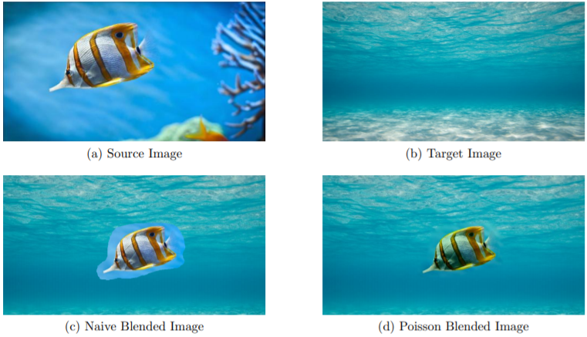

**POISSION BLENDING**

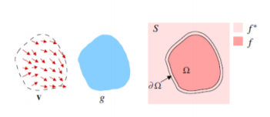Poisson Blending algorithm description has been derived from image below illustrates the notations. Let S, a closed subset of R2, be the image domain and let Ω be a closed subset of S with boundary ∂Ω. Let f be the unknown scalar function defined over Ω and f ∗ be the known function defined over S minus the interior of Ω. Let v be the guidance vector field.

The interpolant *f* of *f* ∗ over Ω is the membrane interpolant defined as the solution of the minimization problem.

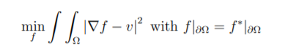

whose solution is the unique solution of Poisson equation with Dirichlet boundary conditions.

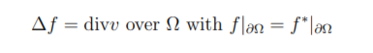

where div *v* = ∂v1/∂x + ∂v2/∂x is the divergence of *v = (v1, v2).* Equation above is independently solved for three channels of the image in RGB color space to obtain the interpolant f.

**IMPLEMENTATION**

The input consists of three components: a source, a target, and a mask which defines which region of the target are to be maintained, and which regions of the source are to be brought to the target. The mask is a binary image: a 0 means the target background should be maintained, while a 1 means the source object should be copied over.

All three images need to be the same size during the blending process. This can be true at the outset, or the source and/or mask can be cropped/extrapolated as needed to fit the target image. The images must be the same size because the matrix manipulations of the algorithm require it.

Speaking of matrix manipulations, the actual algorithm requires solving a system of matrix equations. Because each pixel serves as an unknown in the output image, the matrices can get quite large.

The first matrix, A, is a sparse height*width × height*width. This ensures every pixel has its own column in the system of equations. The second matrix, b, is a column vector of height height*width.

These matrices are filled by iterating over the mask and determine which values to choose for each pixel. If the mask is 0 at a certain pixel, then that pixel in the final output will be the same as the target pixel. This means that matrix A would get a 1 at that pixel index, and matrix b would receive the pixel value of the target. However, if mask has a 1 at that pixel, then we must calculate the gradient of the source image.

The gradient was determined using a discrete Laplacian with at most four neighbors. Wherever we must calculate the gradient of the source, the A matrix at that pixel gets a 4 at that pixel value. Then, the neighboring pixels in the source image (left, right, above, and below) get a -1 in matrix A. In other words, the column in A that corresponds to the neighboring pixel in the source and the row in A that matches that of the current pixel receives the value of -1. The value of b at that pixel index is calculated using the following equation:

4*s(i,j) - s(i-1, j) - s(i+1, j) - s(i, j-1) - s(i, j+1)

where s(i,j) is the source image, and (i,j) are the columns and rows of that image.

Once A and b are filled, we can solve the system of equations. To set up the equation, we have Ax = b where x is the output column vector. Once the system is solved, x is simply reshaped back to the normal dimensions of the target image.

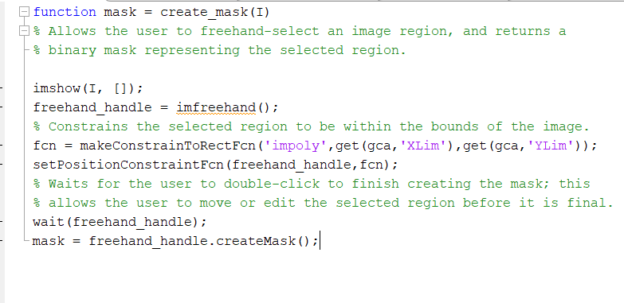**CODE**

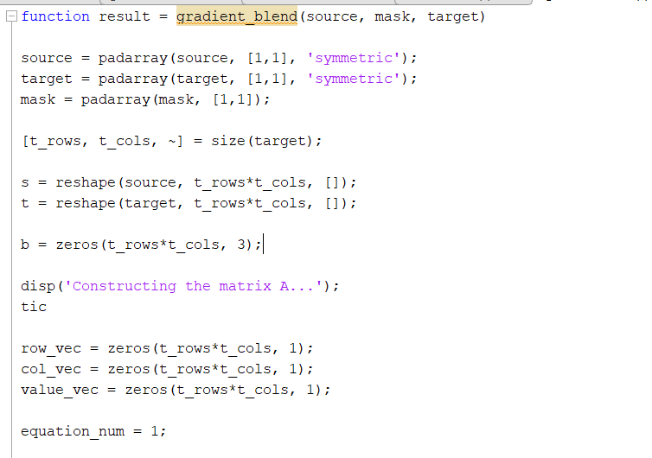

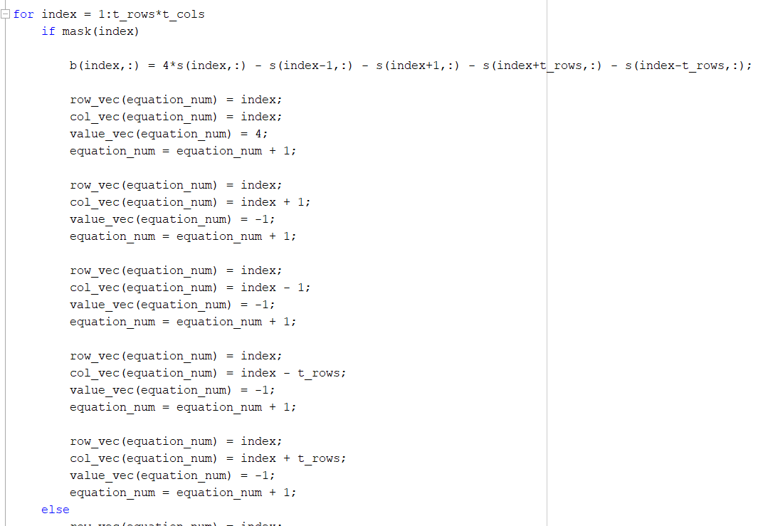

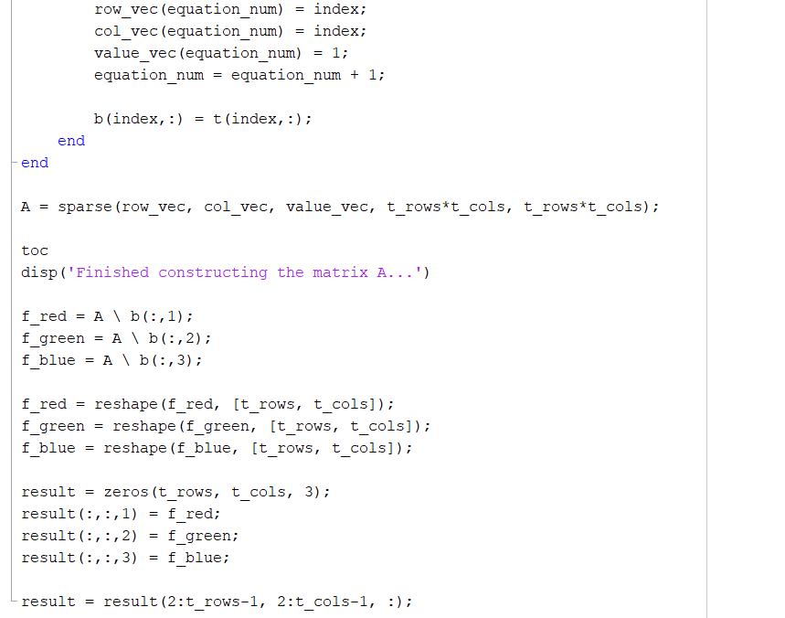

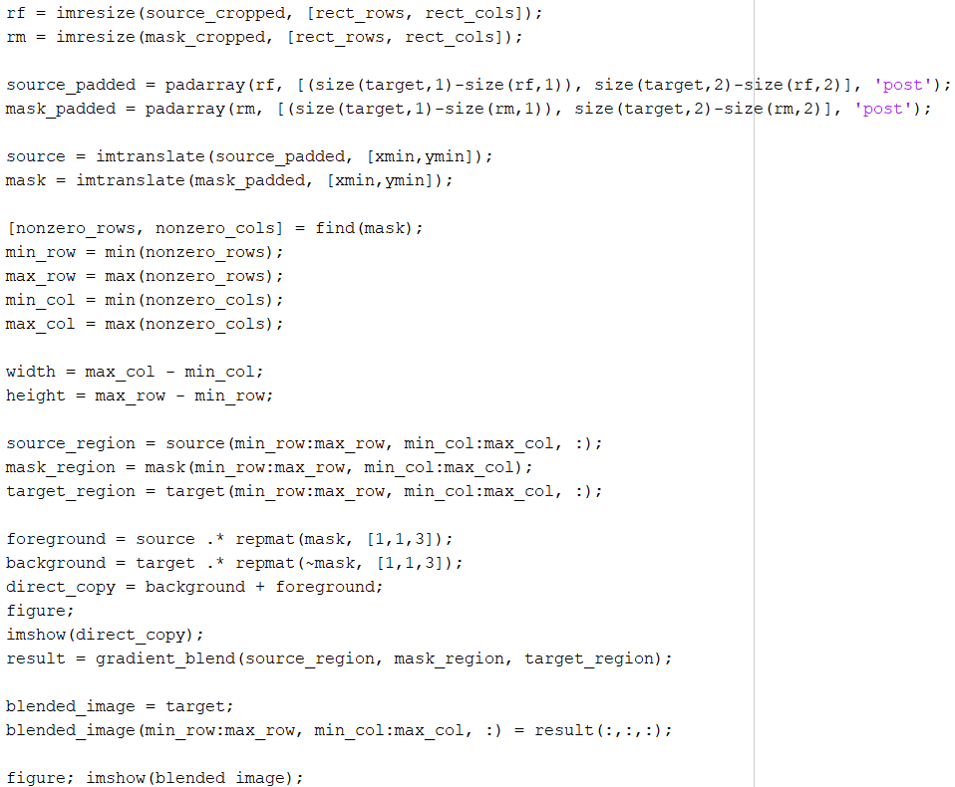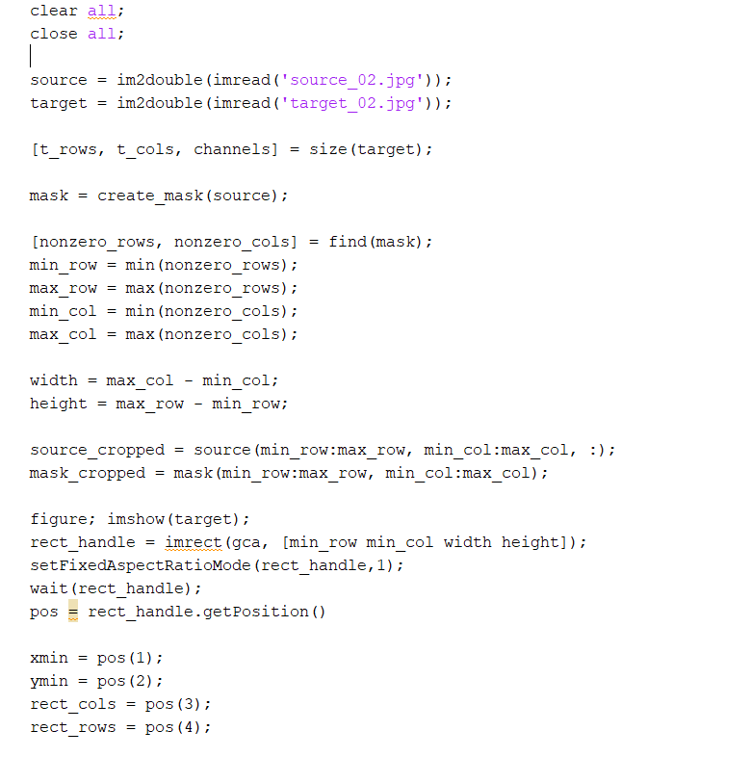

**RESULT**

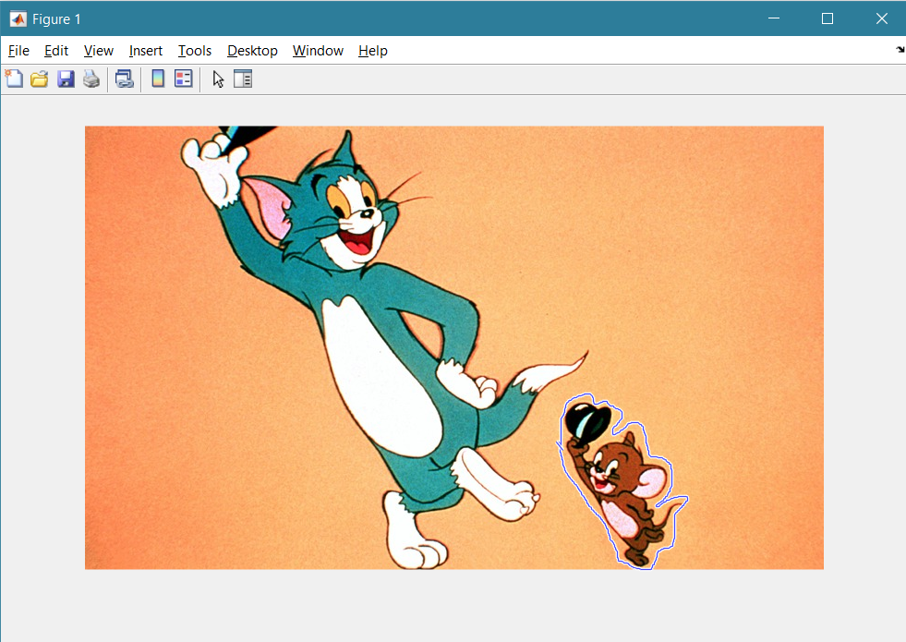 **CASE 1:**

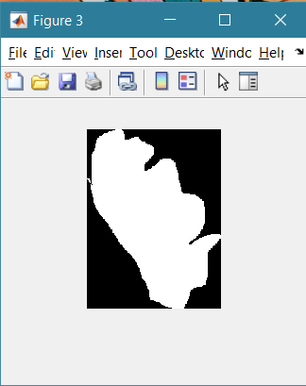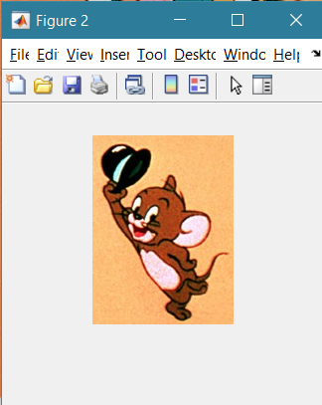

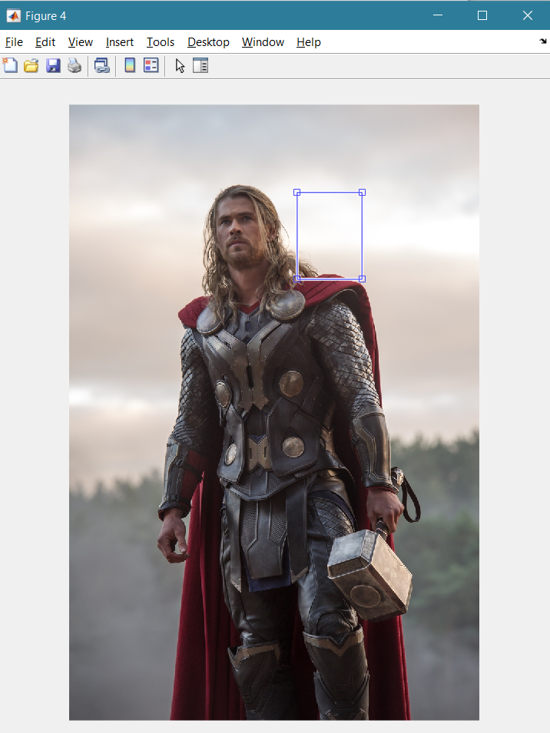

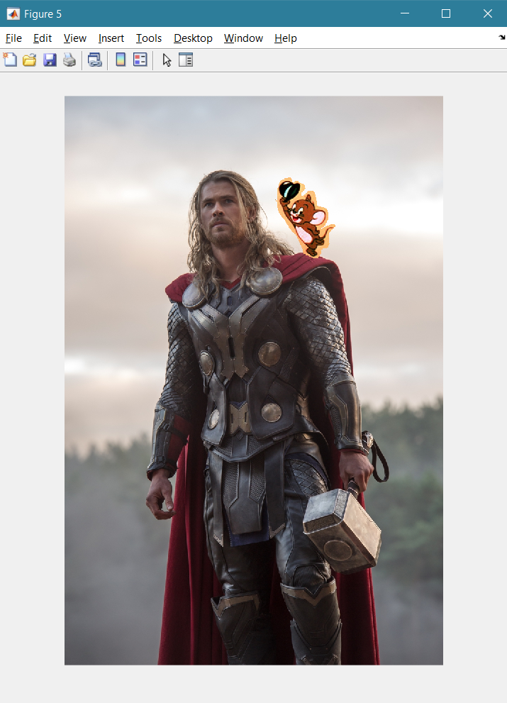

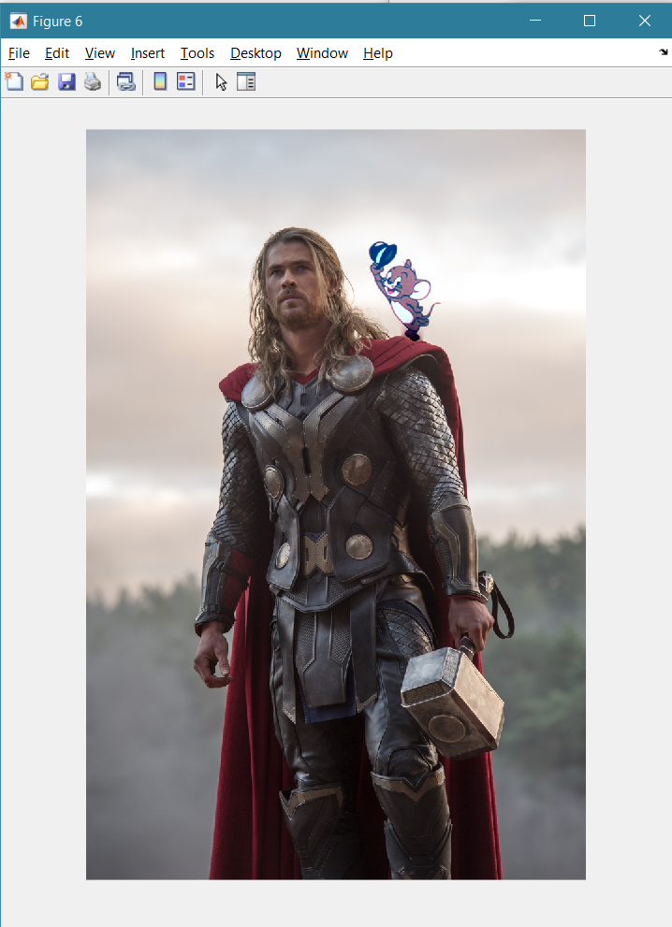

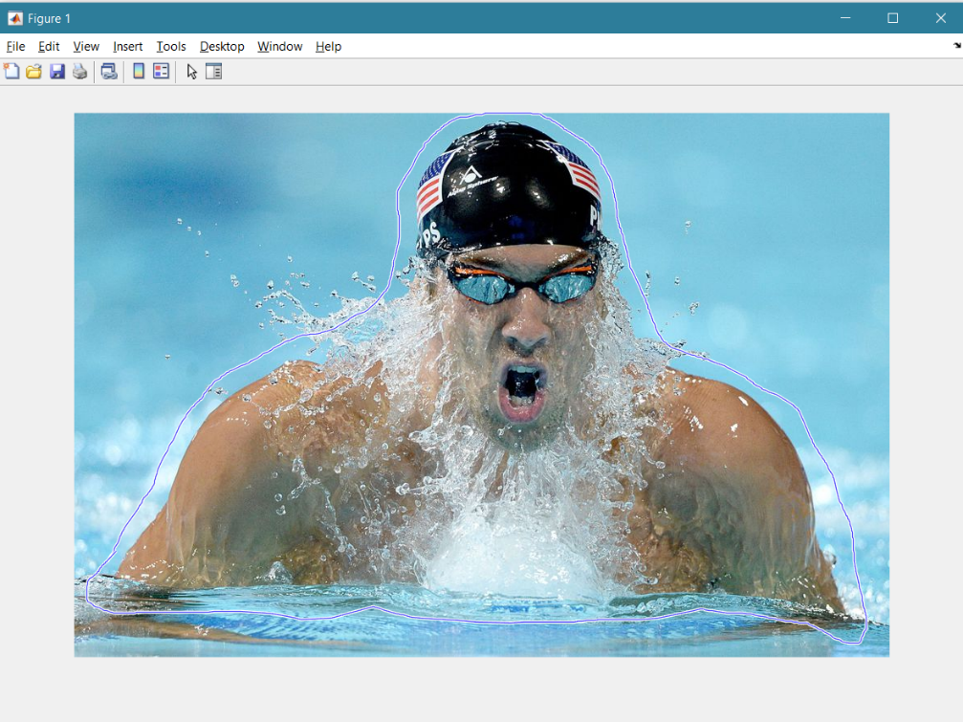**CASE 2**

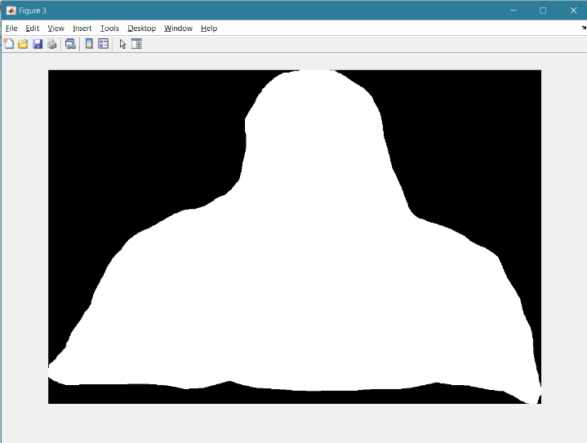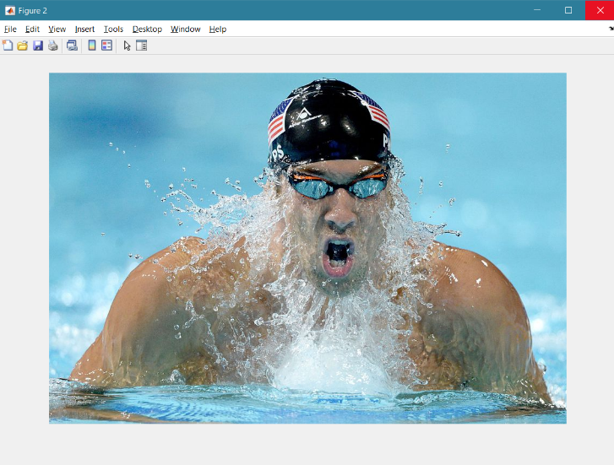

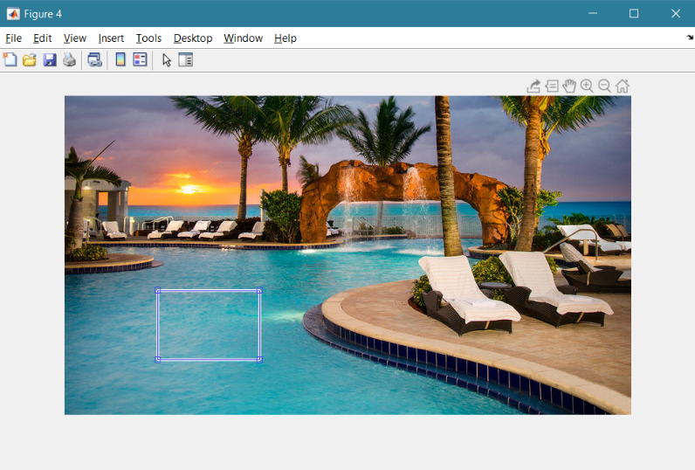

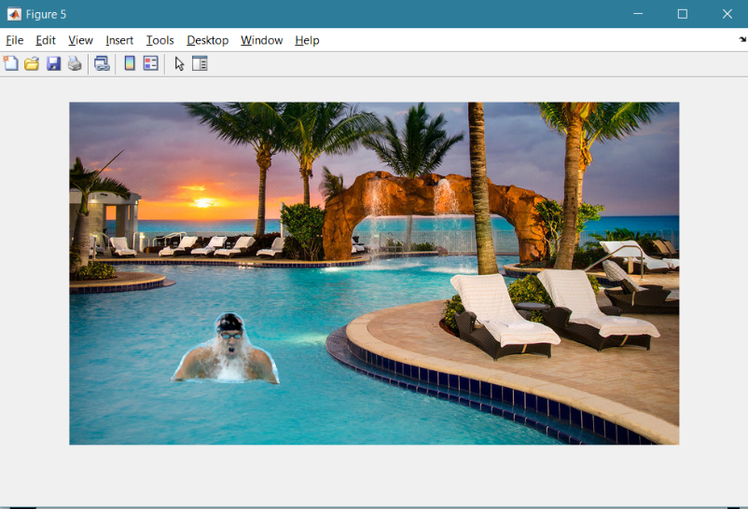

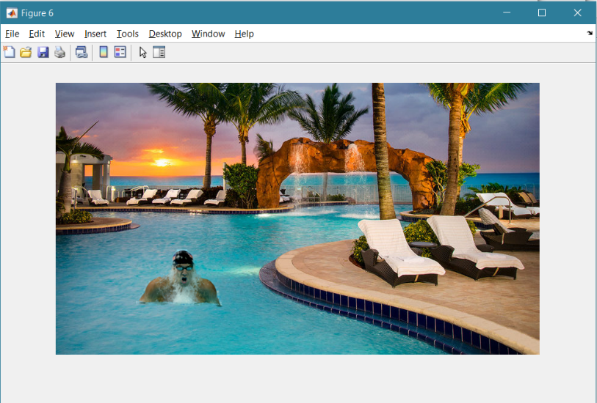

**CONCLUSION**

Poisson method performed well when the images to be blended were of similar colour in nature. Significant variations in colours of the images resulted in colour distortions in the blended images which in some cases resulted in visible seams. The extent of possible changes ranges from replacement by, or mixing with, another source image region, to alterations of some aspects of the original image inside the selection, such as texture, illumination, or colour. An important common characteristic of all these tools is that there is no need for precise object delineation, in contrast with the classic tools that address similar tasks.

**REFERENCE**

1.<https://www.cs.jhu.edu/~misha/Fall07/Papers/Perez03.pdf>

2.<https://www.ipol.im/pub/art/2016/163/article_lr.pdf>